WEEK13

Q1)Givenanarrayofnumbers,findtheindexofthesmallestarrayelement(thepivot),forwhichthe sums of all elements to the left and to the right are equal. The array may not be reordered.

Example

arr=[1,2,3,4,6]

* thesumofthefirstthreeelements,1+2+3=6.Thevalueofthelastelementis6.
* Usingzerobasedindexing,arr[3]=4isthepivotbetweenthetwosubarrays.
* Theindexofthepivotis3. Function Description

CompletethefunctionbalancedSumintheeditorbelow. balancedSum has the following parameter(s):

intarr[n]:anarrayofintegers Returns:

int:anintegerrepresentingtheindexofthepivot Constraints

* 3 ≤n ≤105
* 1≤arr[i]≤2×104,where0≤i<n
* Itisguaranteedthatasolutionalwaysexists Input Format for Custom Testing

Inputfromstdinwillbeprocessedasfollowsandpassedtothefunction. The first line contains an integer n, the size of the array arr.

Eachofthenextnlinescontainsaninteger,arr[i],where0≤i< n.

SampleCase0

Sampleinput0

STDIN FunctionParameters

4 →arr[]sizen=4

1 →arr=[1,2,3,3]

2

3

3

SampleOutput0

2

Explanation0

* Thesumofthefirsttwoelements,1+2=3.Thevalueofthelastelementis3.
* Usingzerobasedindexing,arr[2]=3isthepivotbetweenthetwosubarrays.
* Theindexofthepivotis2.

SampleCase1

SampleInput1

STDIN FunctionParameters

3 →arr[]sizen=3

1 →arr= [1,2,1]

2

1

SampleOutput1

1

Explanation1

* Thefirstandlastelementsareequalto1.
* Usingzerobasedindexing,arr[1]=2isthepivotbetweenthetwosubarrays.
* Theindexofthepivotis1.

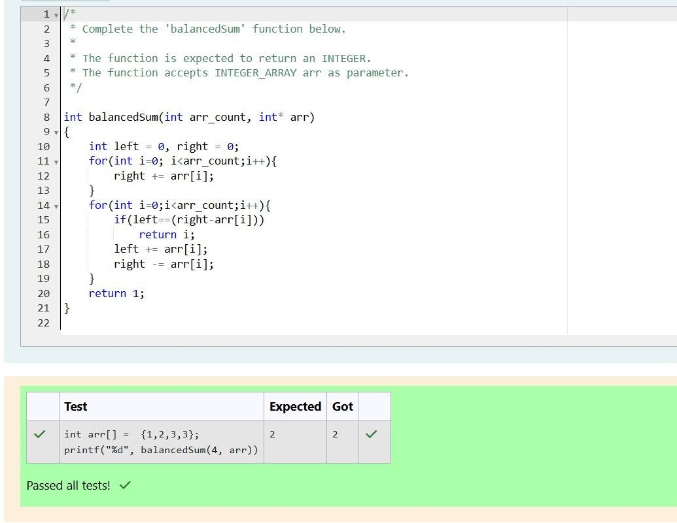

Q2)Calculatethesumofanarrayofintegers.

Example

numbers=[3,13,4,11,9]

Thesumis3+13+4+11+9=40. Function Description

CompletethefunctionarraySumintheeditorbelow. arraySum has the following parameter(s):

intnumbers[n]:anarrayofintegers Returns

int:integersumofthenumbersarray Constraints

1 ≤ n≤104

1. ≤numbers[i]≤ 104

InputFormatforCustomTesting

Inputfromstdinwillbeprocessedasfollowsandpassedtothefunction. The first line contains an integer n, the size of the array numbers.

Eachofthenextnlinescontainsanintegernumbers[i]where0≤i<n.

SampleCase0

Sample Input 0 STDIN Function

|  |  |  |
| --- | --- | --- |
| 5 | → | numbers[]sizen=5 |
| 1 | → | numbers=[1,2,3,4,5] |
| 2 |  | |
| 3 |
| 4 |
| 5 |

SampleOutput0

15

Explanation0

1 +2+ 3+4 +5=15.

SampleCase1

Sample Input 1 STDIN Function

1. →numbers[]sizen=2

12 →numbers=[12,12]

12

SampleOutput1

24

Explanation1

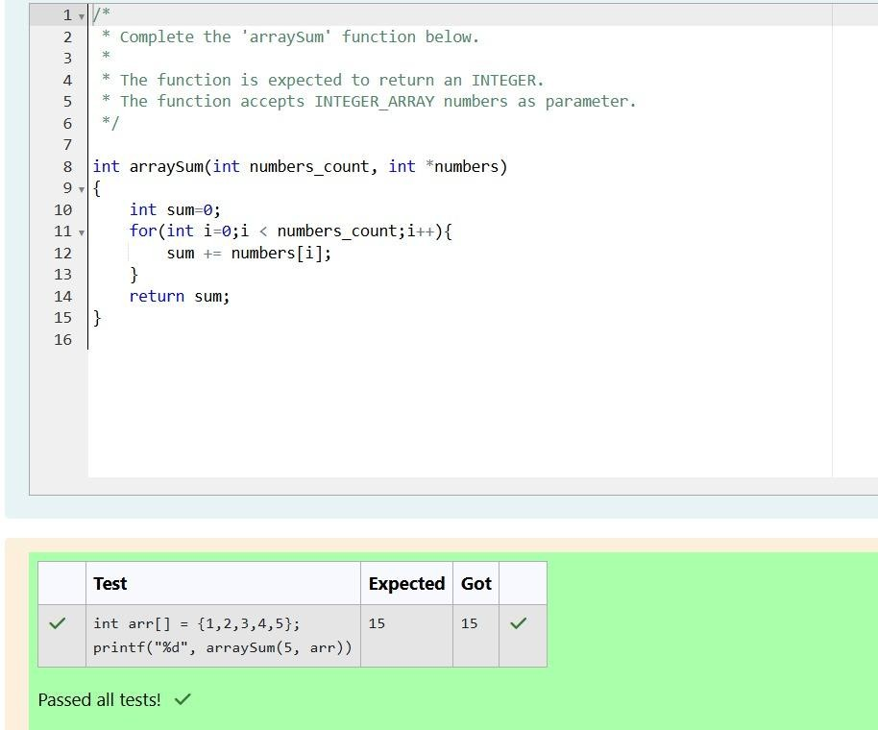12+12= 24.

Q3) Given an array of n integers, rearrange them so that the sum of the absolute differences of all adjacentelementsisminimized.Then,computethesumofthoseabsolutedifferences.Examplen=5arr

=[1,3,3,2,4]Ifthelistisrearrangedasarr'=[1,2,3,3,4],theabsolutedifferencesare|1 -2|=1,|2- 3| = 1, |3 - 3| = 0, |3 - 4| = 1. The sum of those differences is 1 + 1 + 0 + 1 = 3. Function Description Complete the functionminDiff intheeditorbelow. minDiff hasthe followingparameter: arr: an integer array Returns: int: the sumof the absolute differences of adjacent elements Constraints 2 ≤ n ≤105 0 ≤

arr[i]≤109,where0≤i<nInputFormatForCustomTestingThefirstlineofinputcontainsaninteger,n, the size of arr. Each of the following n lines contains an integer that describes arr[i] (where 0 ≤ i < n).

SampleCase0SampleInputForCustomTestingSTDINFunction 5→arr[]sizen=55→arr[]

= [5, 1, 3, 7, 3] 1 3 7 3 Sample Output 6 Explanation n= 5 arr = [5, 1, 3, 7, 3] If arr is rearranged asarr' = [1, 3, 3, 5, 7], the differences are minimized. The final answer is |1 - 3| + |3 - 3| + |3 - 5| + |5 - 7| = 6. Sample Case 1 Sample Input For Custom Testing STDIN Function 2→arr[]sizen=23→arr[]

=[3,2]2SampleOutput1Explanationn=2arr=[3,2]Thereisnoneedtorearrangebecausethereare only two elements. The final answer is |3 - 2| = 1.

